

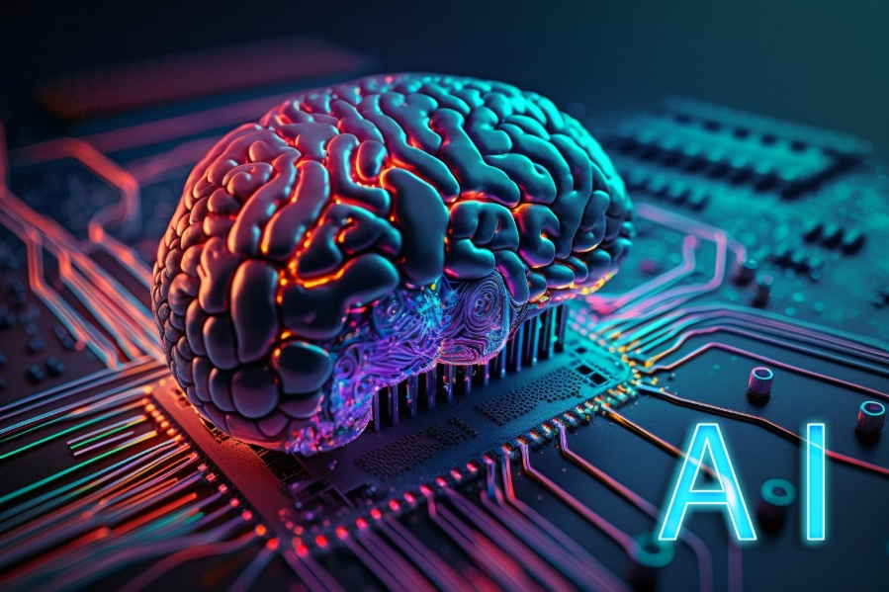

- Student name: omar Abuhassan
- student ID Number: 22110264
- Major: Data Science and Artificial Intelligence
- Academic Year: 2nd
- Course Tutor: Batool Alarmouti

Introduction
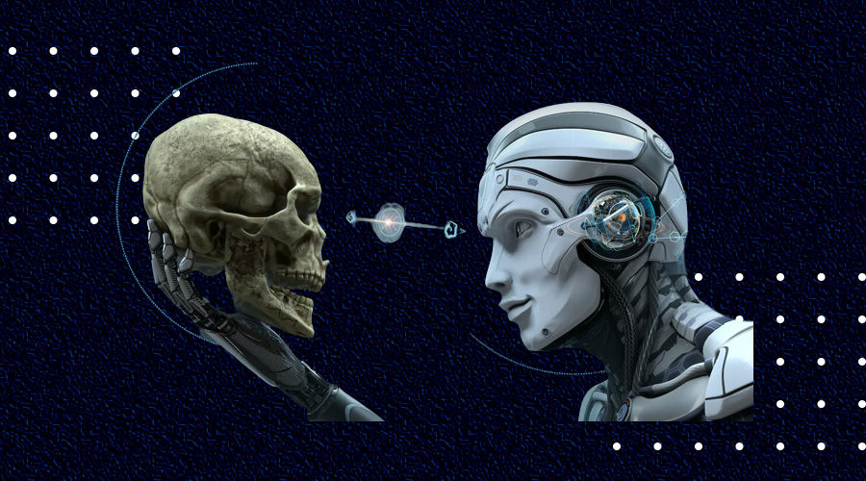
Recently, after the spread of artificial intelligence in and its intervention in most of the existing fields, it was necessary to reconsider and think about its introduction into the medical field, because it has a huge database, which undoubtedly will be of great benefit, which will help doctors in choosing the most appropriate procedures and avoid medical errors significantly, which will help improve the medical sector And to preserve the souls of people.
Artificial intelligence is already playing a significant role in the medical fields, and it has a high potential because of its capabilities to improve and develop itself, so it is able to improve patient outcomes, according to the Medical Library in the USA, "we expect to see limited use of artificial intelligence in clinical practice within 5 years and more extensive use within 10 years."
Here we should note that artificial intelligence has a role that should not be neglected in the medical field, and it should be developed so that doctors can create analyzes for the Prevention of diseases with its help, in addition to working on the creation of new drugs for diseases for which doctors have not yet been able to discover drugs.
Currently, the most important medical fields in which artificial intelligence is used:
1) diagnosis of patients: where he analyzes the data in the reports and images ( X-ray ,resonance, …., Etc.), and this helps doctors in a faster and more accurate diagnosis of the patient.
2) copying medical documents: modern technologies are used through which artificial intelligence converts spoken speech into written speech, which preserves the patient's data from oblivion and saves them in an organized and tidy way.
3) Drug Discovery: artificial intelligence collects patient data and analyzes their cases so that they can be developed from existing drugs or in order to make drugs that did not exist before.
Because artificial intelligence is created and used by humans, there is no doubt that as it has many advantages, it has disadvantages, so I will mention here the most important points of both parties
Advantages:
1) it serves to increase the efficiency of diagnostics
2) facilitates paperwork and administrative tasks
3) promotes research methods and helps in constructive discoveries that will contribute to the development of Medicine
Disadvantages:
1) fear of the correctness and accuracy of the decision to be made
2) Fear of saving data and encroaching on the privacy of patients
3) fear of taking away some jobs from humans in relation to administrative tasks
Bottom-Up Approaches:
Symbolic AI (Good Old AI)
Symbolic Artificial Intelligence
1. Symbolic AI (Good Old AI)
Symbolic AI uses clear symbols and rules to represent knowledge and logic. It relies on manipulating symbols to perform tasks such as thinking, solving problems, and understanding language.
Techniques:
Rules-based systems: Systems that use a set of if-then rules to draw conclusions or actions.
Knowledge representation: Methods of representing knowledge in a structured form, such as semantic networks or ontologies.
Advantages:
Explainability: Symbolic AI systems provide clear and understandable pathways of thinking.
Formal logic: Uses established logical frameworks to ensure their correctness.
Cons:
Scalability: You have difficulty dealing with large and complex datasets.
Flexibility: Less adaptable to new or unexpected data.
2. Symbolic artificial intelligence
Non-symbolic AI, also known as sub-AI, involves models that learn from data without relying on predefined rules. These systems often rely on statistical methods and neural networks.
Techniques:
Artificial neural networks (ANNs): models inspired by the human brain, capable of learning from large data sets.
Machine learning: Algorithms that improve their performance based on data, including supervised and unsupervised learning, and reinforcement learning.
Advantages:
Adaptability: Can handle large and complex datasets and adapt to new data.
Performance: It often outperforms symbolic AI in tasks such as image recognition and speech.

Cons:
Explainability: Models can be opaque, making decision-making processes difficult to understand.
Training data: Requires large amounts of high-quality data for training.
Techniques & Tools
Technique | Tools | Advantages | Disadvantages
Artificial Neural Networks | TensorFlow, PyTorch, Keras | Effective for complex patterns, handles large datasets | Requires significant computational resources, opaque
Machine Learning | scikit-learn, Pandas, NumPy | Automates decision-making, improves with data | Requires large data, data quality dependency
Reinforcement Learning | OpenAI Gym, TensorFlow Agents, PyBullet | Learns optimal strategies, effective in dynamic environments | Computationally intensive, needs defined rewards
Evolutionary Algorithms | DEAP, TPOT, PyEvolve | Good for optimization, explores diverse solutions | Many iterations needed, computationally expensive
Bottom-up AI technologies focus on building intelligent systems from adaptable, data-driven models that can handle complex patterns and large datasets. They offer flexibility and high performance but often come with significant computational requirements and challenges in the possibility of model interpretation.
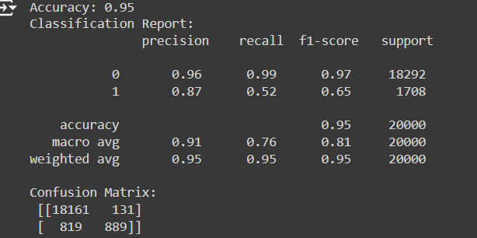Class 0 (more prevalent class):
High precision (0.96), recall (0.99), and f1-score (0.97), indicating that the model performs very well for this class.
Class 1 (less prevalent class):
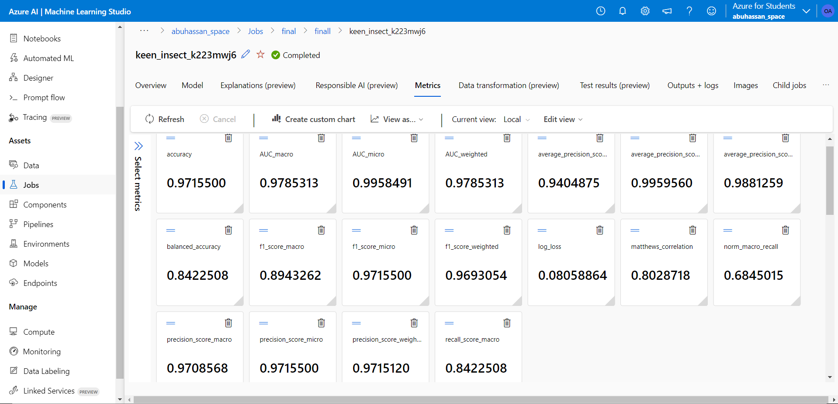
Lower precision (0.87), recall (0.52), and f1-score (0.65), indicating that the model is less effective at predicting this class.

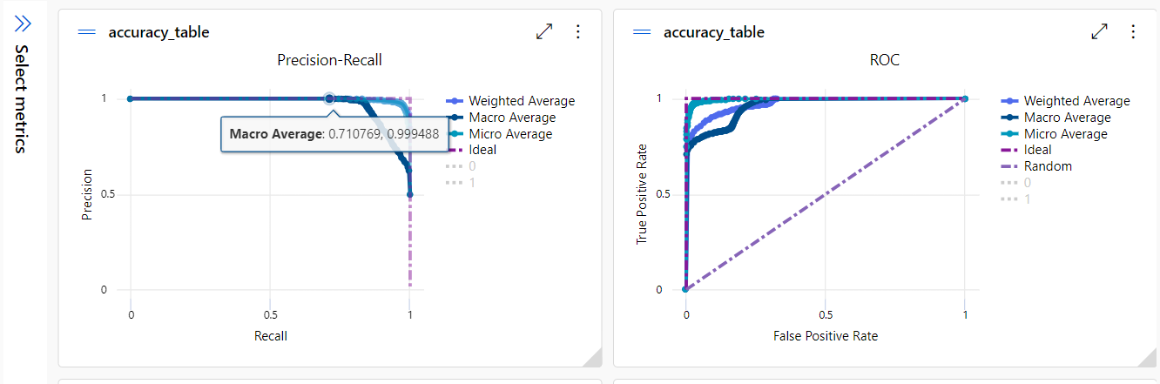

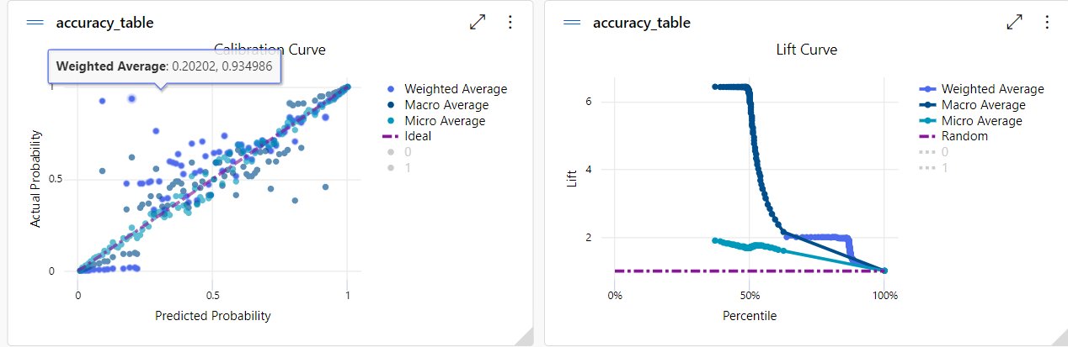
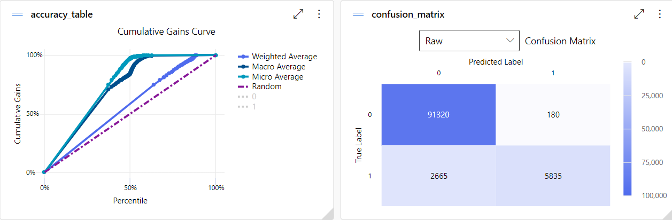
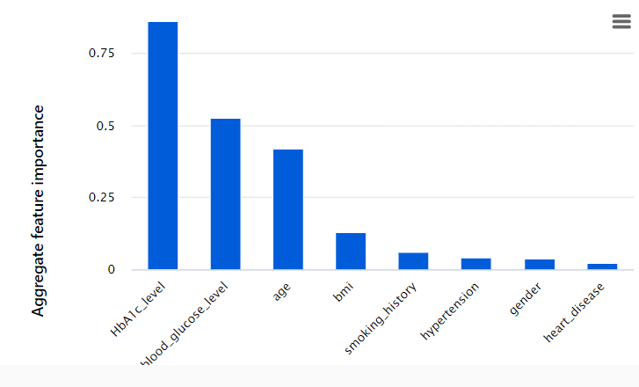

Top-down Approach:
Top-down approaches to deploying modern intelligent systems involve starting with a broad understanding of the problem or task and then breaking it down into smaller, manageable components. This is in contrast to bottom-up methods that build complex systems from simpler components. Here are some of the techniques and tools associated with the top-down approach, as well as their advantages and disadvantages:
Technique | tools | Advantages | Disadvantages
Knowledge Engineering | Prolog, Jess | - Transparency: Explicit rules are understandable and modifiable by experts. | - Brittleness: Rules may not generalize well to new situations.
 |  | Interpretability: Decisions are explainable based on explicit rules. | - Maintenance: Updating rules can be time-consuming and require expertise.
 |  | - Scalability: Can handle large knowledge bases. | - Limited Learning: Difficulty in learning from data or adapting to dynamic environments.
Semantic Technologies | OWL, RDF | - Rich Representations: Ontologies provide a structured way to represent complex knowledge. | - Complexity: Developing and maintaining ontologies can be complex and time-consuming.
 |  | - Interoperability: Enables integration of heterogeneous data sources. | - Scalability: Large ontologies can become computationally expensive to reason with.

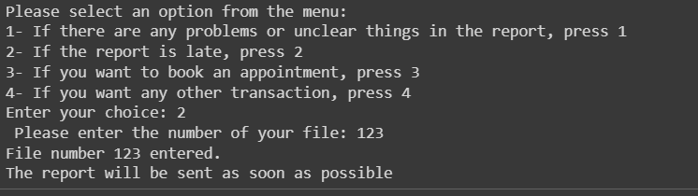
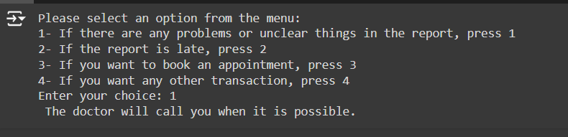
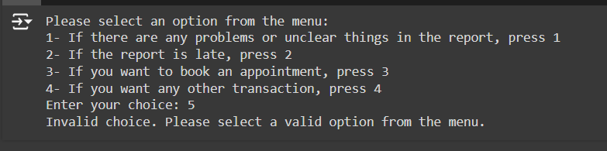
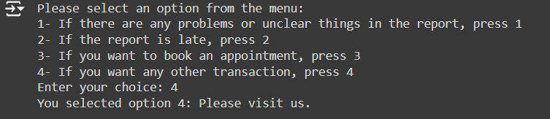
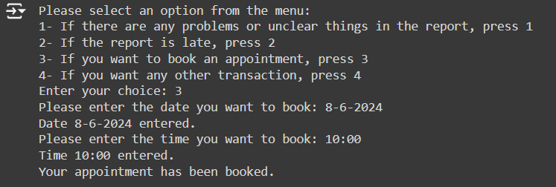

Intelligent Systems Deployment
- Integrating AI Approaches
In order to achieve the best and optimal job performance, integration is required in multiple artificial intelligence methods, and the most famous artificial intelligence approaches are:
- Machine Learning (ML)
- Natural Language Processing (NLP)
- Computer Vision
- Expert Systems
Next, I will explain how these curricula are integrated.
- Machine Learning
It is what makes the system able to learn from data, and makes it able to predict and improve through algorithms that are the basic building block of most smart systems

- They are applied through:
- Data processing: where data is cleaned, processed and processed
- Training: Systems are trained by previously processed data
- Integration: Because of its benefits, it is included in the system in order to predict and detect anomalies

- Natural Language Processing
It works to make systems able to understand human languages, and this is very important because it is the main pillar of automated chat programs (chatbot)

- They are applied through:
- Analysis: It analyzes text data using some techniques such as coding, cutting and transforming
- Language models: Pre-trained language models such as:
- ChatGPT
- Gemini
- copilot
- Integration: Its components are integrated to create functions such as:
- Summarizing texts
- Automated customer support

- Computer Vision
Allows systems to interpret and understand information from the real world

- They are applied through:
- Image processing: processes images and videos by improving quality, resizing, normalizing
- Feature extraction: Techniques such as CNNs are used to extract featured objects in images
- Integration: They are integrated into systems and help in facial recognition, image classification (this is what major social media companies use to block content that supports the Palestinian cause)

- Expert Systems
It uses rule-based logic to simulate humans' ability to make decisions.

- They are applied through:
- Base building: A comprehensive knowledge base is created that contains all the rules and data for the selected field
- Inference: Applies logical rules to cognitive rules in order to infer information or make decisions
- Integration: Integrated with systems to provide support in decision-making and to help solve complex problems
Intelligent Systems Deployment
It requires the successful deployment of smart systems to a strong base in order to support the integration of the components of the artificial intelligence system, and this matter includes

- Middleware software: It ensures easy communication and data flow by acting as an intermediary between the components of the system
- Application Interface Integration (API): Used to communicate and interact with system components
- Data pipelines: They are created to ensure that data is processed and moved between components as quickly as possible.

Potential impact on users and organizations in the medical field
The deployment of systems in the medical field can lead to a medical revolution, which will positively affect patients, doctors (users) and hospitals (organizations) due to the improvements it will provide in diagnosis, treatment, patient management and efficiency.

- Impact on users (patients and doctors)
- Diagnosis and treatment:
- Early detection: Through artificial intelligence systems, medical reports and medical images such as:
(X-ray, MRI, CT scan)
Through analysis, problems can be detected faster and more accurately.
- Treatment plans: Through machine learning algorithms, treatment plans and recommendations can be provided to patients based on their health condition and medical history.

- Improving the patient experience:
- Virtual Assistant: This personal assistant, which works through NLP, can provide real-time medical advice to patients and make a complete schedule of medication times.

- Accessibility and inclusivity:
- Accessibility: Helps patients with hearing disabilities, especially hearing disabilities, by recognizing sounds and converting them into texts or vice versa
- Language translation: Through neural programming, it works to facilitate communication between patients and doctors if they do not speak the same language

- Patient monitoring and management:
- Wearables: These devices can keep up to date with patients' readings and indicate the impression in the event of any sudden change in the readings
- Chronic disease monitoring: By tracking readings and processing patient historical data, a complete perception of ongoing treatment insights can be provided.

- Impact on healthcare organizations:
- Practical efficiency:
- Task management: The system can complete routine tasks such as: managing patient records and preparing invoices, which leads to reducing the burden on employees
- Resource optimization: Through analytics, resource consumption and management can be optimized, which leads to cost savings and better service

- Clinical Decision Support:
- Enhance decision-making: Through machine learning, dishes can be assisted in patients' decision-making
- Risk assessment: By analyzing patient data, patients can be identified as most at risk, allowing doctors to intervene immediately, which can preserve patients' lives.

- Data-driven vision:
- R&D: By analyzing huge amounts of patient data, it is possible to identify the trends that require support and development

- Compliance and Reporting:
- Regulatory Compliance: The system can assist in compliance with healthcare rules by completing the required documentation and reporting processes for regulatory bodies.
- Quality Control: Through monitoring reports, the continuity of adherence to best practices and standards is ensured.

The impact of artificial intelligence on the world in the last two decades
Artificial intelligence has recently revolutionized all areas of life, this sudden revolution has led to the emergence of problems and challenges (which I do not personally believe in), and in this part I will address some of what the world sees as challenges and problems

- Security issues:
- Data Privacy and Protection:
Artificial intelligence systems depend on huge amounts of data, and from this data may be sensitive and personal data, and protecting this data is a problem and a source of concern for many users

The most prominent challenges related to this issue:
- Data breaches: AI systems are frequently attacked, which puts data at risk of hacking
- Data anonymization: Maintaining data anonymity without losing its usefulness is complicated

- Hostile attacks:
Attacks involve manipulation of inputs that may lead to wrong or unwanted answers.

The most prominent challenges related to this issue:
- Durability: It is difficult to develop a system that is so robust that it prevents such attacks
- Detection and mitigation: It is very difficult to detect such types because they need high-cost monitoring systems

- Ethical issues:
- Bias and fairness: Artificial intelligence can be biased to a certain category of people because of the way it was trained
(which is indeed what we see when asking any linguistic system about any topic related to the issue of Palestine, especially after the events of the seventh of October, when asked about violations against the Palestinians, it will be answered that it is a linguistic system and cannot answer questions related to any political topic, and in return when asked about violations against Israelis - which do not exist in the first place - he will answer that there is murder and lack of respect for international conventions and human rights)

The most prominent challenges related to this issue:
- Bias detection: Bias is one of the sensitive topics that are difficult to detect due to different views on some issues

- Standards of justice: Due to the difference in the meaning of justice from one person to another and from one country to another, this is one of the most difficult challenges that are being worked on

- Transparency and Accountability:
AI systems are completely confidential, which makes it difficult or even impossible to understand the decision-making processes it makes.

The most prominent challenges related to this issue:
- Explainability and accountability:
Creating an artificial intelligence system capable of interpreting the decisions it makes in clear words is necessary, but it is a fantasy.
- Technical challenges in the development of smart systems:
- Data Quality and Availability:
The need for large, high-quality, large-scale datasets to be trained on them
The most prominent challenges:
- Data collection: Collecting and organizing data is a very complex challenge and solution.
- Data quality: Ensure the correctness and accuracy of the data and are connected to each other

- Integration and Deployment:
The AI system involves many technical hurdles
The most prominent challenges:
Operability and maintenance: Ensuring the software runs smoothly as well as monitoring and updating AI in the long term is a problem in itself
- Legal implications:
- Intellectual Property Rights:
Ownership of AI-generated content is a complex problem.

Challenges:
Eligibility to obtain a patent and copyright: Opinions differed about who has the right to obtain a patent from inventions generated from artificial intelligence or copyright for written results

